(Approx. 1334 words)

File Encryption
By Dick Maybach, Member, Brookdale Computer Users’ Group, NJ
July 2016 issue, BUG Bytes
www.bcug.com
n2nd (at) att.net

I wrote an article on file encryption that appeared in the August 2014 Bytes, available at http://www.bcug.com. While I was writing, TrueCrypt, a popular tool for this task, was discontinued by its anonymous developers amid speculation that it had been compromised. As a result, I recommended using GnuPG for file encryption. This is still valid advice, but two successors to TrueCrypt have since appeared, CipherShed, http://ciphershed.org/, and VeraCrypt, http://veracrypt.codeplex.com/. Both can read files encrypted with TrueCrypt, but only CipherShed can write in this format. If compatibility with TrueCrypt files is important, you should use CipherShed, otherwise use VeraCrypt, which has somewhat improved security and appears to be the more active project. The remainder of this article will discuss only VeraCrypt, which is available at the CodePlex site given above. You can also get from SourceForge, but this site has been known to include malware with its downloads. SourceForge now has new owners and may again be reliable, but why take a chance?

You may be using GnuPG with its public/private key method to encrypt your e-mail, and as I discussed in my previous article, you can also use it for file encryption. The advantages of doing this are fewer keys to manage and having only one encryption program. However, you may find some features of VeraCrypt useful, and its single-key encryption can be more secure than the GnuPG's public/private type, provided you use a strong password. You should view encryption as a means of reducing, not eliminating risk. If the NSA really wants to decrypt your file, it most likely can.

VeraCrypt creates and maintains on-the-fly-encrypted volumes, and data is automatically encrypted before it is saved. No data stored in an encrypted volume can be read without using the correct password. VeraCrypt stores decrypted data only in RAM; it stores only encrypted data on a disk. Even when the volume is mounted, data on the disk remains encrypted. When you restart or turn off your computer, the volume will be dismounted and files stored in it will be encrypted. To read them, you have to mount the volume with VeraCrypt and provide the correct password.

You can download a 162-page manual from VeraCrypt's Website, but I won't try to cover that here. Instead, I'll walk through establishing and using an encrypted volume to show how easy this is. The screen-shots are from a Linux machine, but the differences for other operating systems are quite minor. Screen 1 shows VeraCrypt's opening screen. (On Windows the slots column would be labeled “Drive” and the rows would be labeled D:, E:, etc.) Your first step will be to create an encrypted volume, which you do by selecting a slot and clicking the Create Volume button.

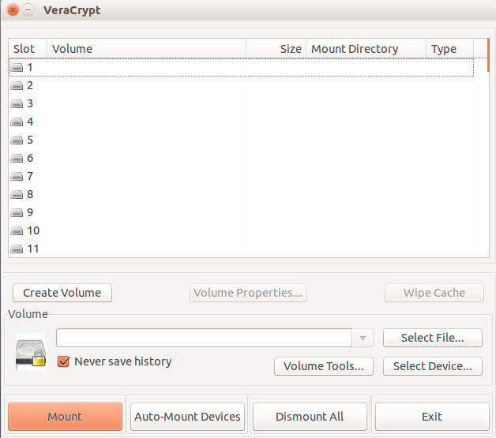
Screen 1. VeraCrypt Main Window

You will then see Screen 2. Select the upper option to create an encrypted volume as a file and the lower to encrypt an entire external device, such as a memory stick. Then click Next to continue.

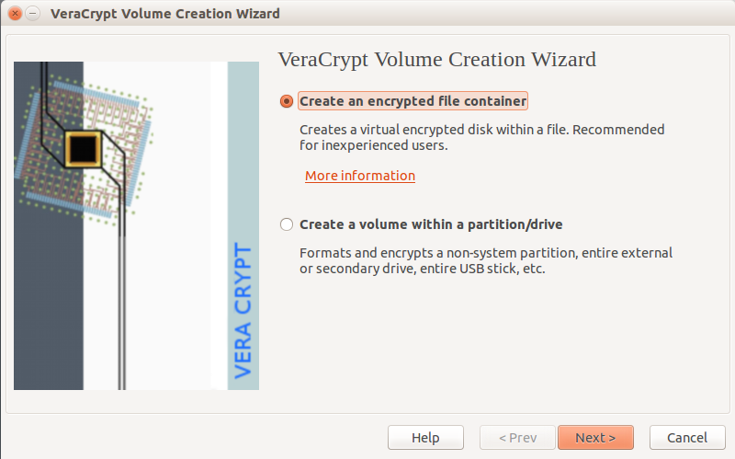
Screen 2. Volume Creation

On Screen, 3 you choose whether the encrypted volume will be visible or hidden. The first choice is by far more common.

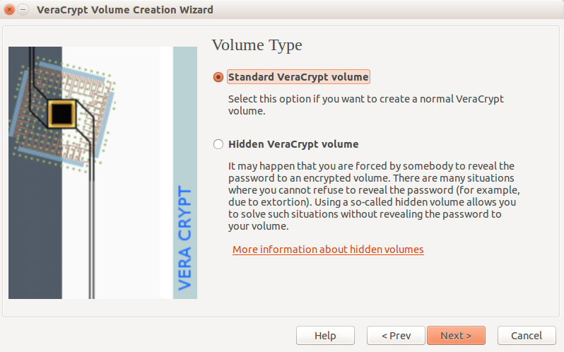
Screen 3. Volume Type

You next specify where to store the volume, Screen 4. Initially the location window will be empty. Just click on Select File..., choose its directory, and enter a filename. Important – be sure to choose a filename different from that of an existing file in the chosen directory, or the existing file will be deleted!

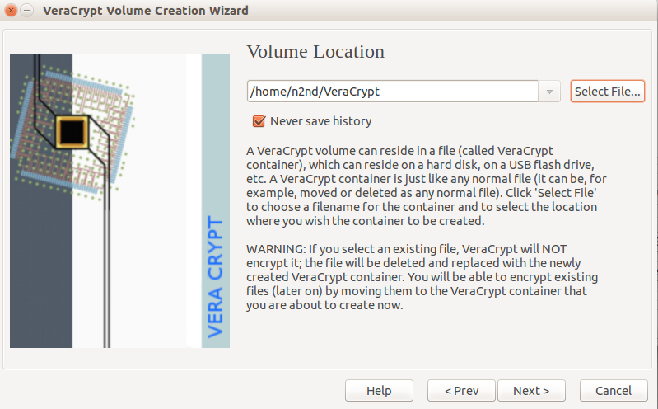
Screen 4. Volume Location

You will then go through screens where you select an encryption method (the default, AES, is fine), a volume size, and a password. Give some thought to the size. If you choose 100 Mbytes, the volume will occupy that much room on your disk, even though it contains only a 1-kbyte file. But if you choose 1 Mbyte and have 10 Mbytes of data, you will have to create another volume with enough capacity for your data. Password choice is also important. For example, if the volume will be stored in the cloud and contains sensitive data, such as passwords to your on-line banking account, you should use a long and obscure password, which you safeguard, perhaps in a password manager such as KeePassX. The password screen also offers additional safeguards, such as key files; see the VeraCrypt manual for more information. You then select a file-system, probably FAT or NTFS for Windows users.

Finally, you'll see Screen 5. Before you click the Format button, move the cursor randomly around the screen, which will increase the strength of the encryption. When you click Format VeraCrypt will create an empty volume with the name and location you specified previously.

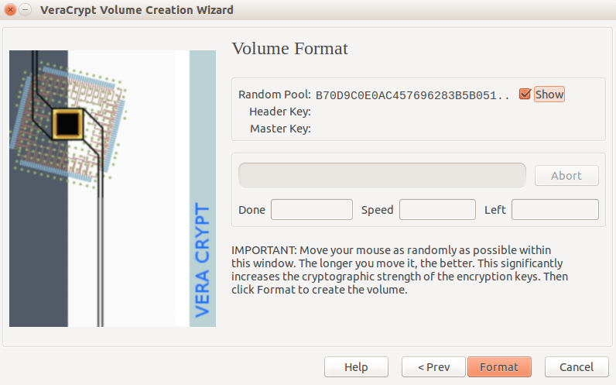
Screen 5. Format Volume

Before you can use the volume, you must mount it. In the VeraCrypt opening screen (Screen 1) click Select File, choose the volume you created, click the Mount button, and enter its password. (Depending on your operating system and permissions, you may also be asked for the administrator password.) Screen 6 shows the result, in this case, the volume is located at home/n2nd/VeraCrypt and is assigned to Slot 1. (On a Windows PC, the column would be labeled “Drive” and you would see the usual drive letters.) I find it convenient to minimize the VeraCrypt window rather than exit the program, so I can recall it quickly to dismount the volume. This isn't really necessary, as it would be dismounted when you log off or power down.

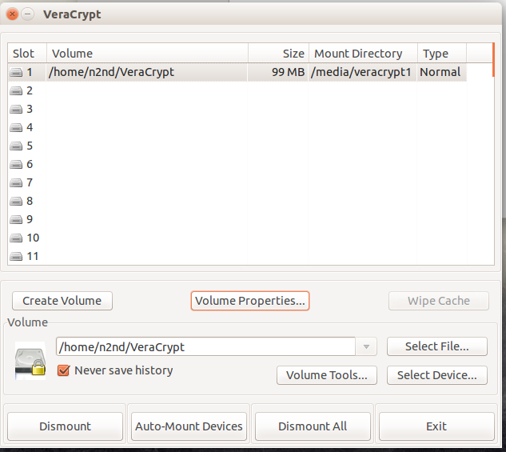
Screen 6. Volume Mounted.

This discussion has been on using a file as a secure volume, but the procedure for using an entire device, such as a USB memory stick or hard drive is the same.

Screen 7 shows the Linux desktop with the file manager open. The encrypted volume is accessed the same as a normal directory. You can copy and paste files to and from it as usual. Linux users should note the mount directory in Screen 6, which shows where to access files from the command line.

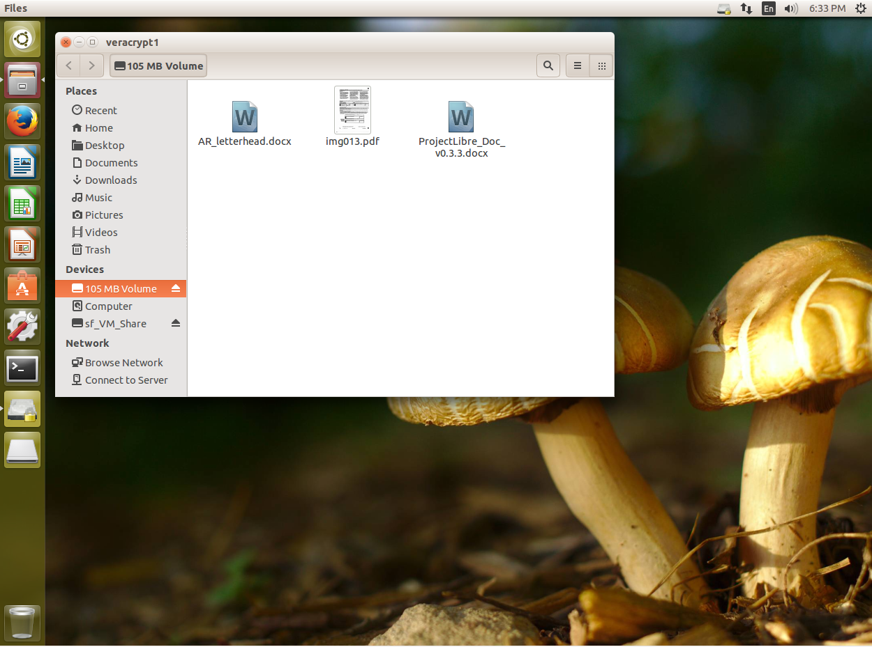
Screen 7. Linux File Manager Accessing a VeraCrypt Volume.

You might be wondering what could possible require a 162-page manual. Although its basic use is quite straight-forward, VeraCrypt has many features, which can make it more convenient and more secure. If your information is sensitive and if the encrypted volume could be accessed by others, for example if it will be stored in the cloud, on a publicly-accessible PC, or a laptop with which you travel, you will want to at least scan the entire manual.

Although both VeraCrypt and GnuPG protect your data using encryption, they do it in quite different ways, GnuPG by encrypting single files and VeraCrypt by creating encrypted volumes. If you want to e-mail a friend some private information, GnuPG will be simpler. and it avoids the issue of securely sending a password. If you have several files containing sensitive data that will stay on your computer or on a memory stick, then creating a secure container with VeraCrypt is preferred. If you will keep the secure container in the cloud or sync it among several computers, its size is important. This is because file sharing is usually done with entire files. If you change one small file in a large encrypted volume, the entire volume must be exchanged, and this probably won't happen until you dismount it. Thus, you must take care to dismount the volume, but stay logged on until the syncing is complete. This isn't an issue with memory sticks, since these are updated incrementally as you change the volume's contents.

Finally, VeraCrypt stresses using hidden encrypted volumes to establish “plausible deniability,” which lets you deny that your computer contains any encrypted data. You shouldn't try to use this casually, for example to bring pirate music or movies into the country, as it could place you in serious conflict with our or another country's authorities.

